Guidelines for Preparing Shipments to Staci | Americas
Staci | Americas and the many vendors who serve our clients have a shared goal: to support our customers’ marketing efforts in the most professional way possible.
The most important step toward a well-managed inventory is the first: Receiving inventory items in a consistently quick and accurate way.

This document provides information that will help ensure that materials are received in a manner that:

- Accurate
- Fast
- Allows invoices to be paid fully and quickly
- Allows material to be stored without damage
- Eliminates double handling

Saves money- Non-conforming receipts are subject to additional charges

Well-labeled boxes and complete packing slips will provide accurate inventory information for the Staci inventory ordering and management system.

By working together, we can contribute to the ongoing success of our mutual customers. Thank you!



PLEASE NOTE – For all facilities: All LTL, Cargo containers and full truck load deliveries must be scheduled at all facilities (See DELIVERY APPOINTMENTS on next page for details). If no appointment is made the driver will need to wait or reschedule. No appointments are necessary for small parcel (Example: UPS/FedEx).

SUWANEE, GA – Staci | Americas
195 SawMill Dr
Suwanee GA 30024
(678) 377-8585 Ext. 2112x2143
Email: julissa.ramirez@staciamericas.com, sanders.baldwin@staciamericas.com
Receiving Hours: 7:00am-3:00pm EST, Monday through Friday

DELIVERY APPOINTMENTS
- Every appointment will be assigned with a confirmation number for the driver.
- If no appointment is made, we cannot guarantee that the delivery will be offloaded right away. The driver may have to wait, and/or the delivery may have to be scheduled for the next business day.
- If the delivery is running late, please contact Staci as soon as possible to make alternate arrangements.
- For regular deliveries, please schedule delivery 24-48 hours in advance. Via Email only
- For cargo containers, please schedule delivery 1 week in advance.


CARTONS
- Cartons should have 200 pounds bursting test.
- Cartons should not weigh more than 50 pounds.
- Each carton should be marked with the:
  - SKU, Stock #, Part #, or Control #
  - Quantity
  - Description
- For a multiple carton shipment, every carton should be uniform in size and type.
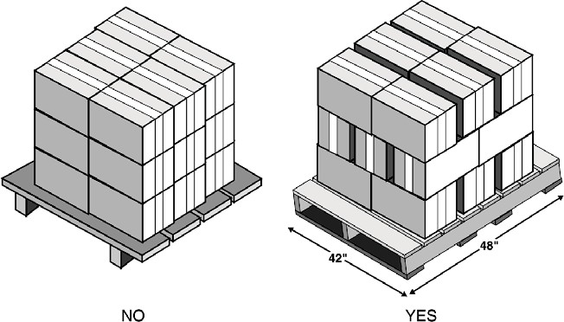
- For a multiple carton shipment, every carton should contain exactly the same quantity of the product; one carton with a lower count is acceptable.
- The partial carton should be clearly marked.
- Cartons should not overhang off of the pallet.

PALLETS
- Pallets of material must be stretch-wrapped.
- Pallets must be wooden and in good condition.
- Pallets should be 48” (L) x 40” (W), and a maximum height of 48” (H) [48” x 40” x 48”].
- The Stock number and quantity markings should be visible on each carton when stacked on the pallet.
- Cartons should be staggered on a pallet to ensure maximum stability.
- Additional charges will be incurred if Staci has to stack loose boxes or re-stack non-conforming pallets.

PACKING SLIPS
  - Each shipment must include a packing list.
  - The packing list must contain the following information:

    - Stock #
    - Item Description
    - Quantity per Carton
    - Carton Count
    - Total Quantity
    - Vendor Name
    - Vendor Phone Number
    - ASN # (if applicable)
    - Client PO# (if applicable)

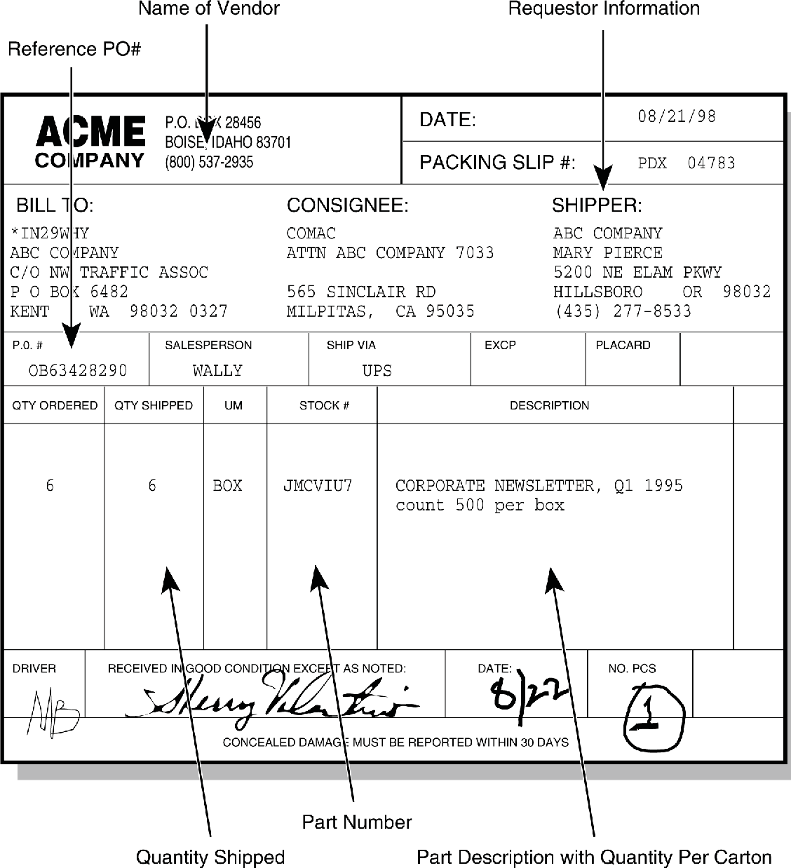

INBOUND APPOINTMENT GUIDELINES

The traffic office can be reached at (678) 377-8585 ext. 2112. If there are any questions or concerns, (if no one answers, please leave a voicemail and we will return your call as soon as possible) please note that all delivery requests are made VIA EMAIL ONLY in writing,

All appointment scheduling via email julissa.ramirez@staciamericas.com, Sanders.baldwin@staciamericas.com

The traffic office can be reached at (678) 377-8585 ext. 2112. If there are any questions or concerns, (if no one answers, please leave a voicemail and we will return your call as soon as possible
reaching via email please also cc the following person(s) as well.

Primary Contact for any questions or concerns:

Sanders.baldwin@staciamericas.com Baldwin, Sanders
Shipping and Receiving Supervisor (678) 377-8585 ext. 2143

**Please be advised that we require a 24-hour notice for all appointments**

If a driver is 30 or more minutes late for their appointment, there will be a $75 late fee due upon arrival and the delivery will be treated as a “work-in”. Also, in addition to the late fee, failing to notify STACI of an ocean freight/floor-loaded container that will be unable to arrive for their scheduled appointment at least 24 hours in advance [emails sent after 3:00pm EST will not be viewed until the following weekday], will also incur a $75 fee. Fee can be paid via Comdata Comchek EFS Check, or Cash. Please keep in mind if paying by check, our traffic office will need a physical hard copy,

The traffic office can be reached at (678) 377-8585 ext. 2112. If there are any questions or concerns, (if no one answers, please leave a voicemail and we will return your call as soon as possible

Thank you,
Your Staci Receiving Team (678) 377-8585 ext. 2112x2143

